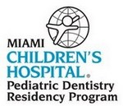
( ) Application Fee: $50

Name: ____________________________________________________
Last First Middle

Permanent Address:____________________________________________

____________________________________________

Mailing Address: ____________________________________________
(if different from above)
____________________________________________

Current Phone #: ___________________ Permanent Phone #: ____________________

Email Address: ______________________________

SS#: ________________________

Date of Birth: _____________________ Gender: ( ) Male ( ) Female

Citizenship: ( ) U.S.A. ( ) Permanent U.S.A. Resident ( ) Other ________________

Visa Status: ______________________________

List names and phone numbers of 3 individuals that may provide additional information regarding your interaction with pediatric patients.

Name Phone

1.________________________________________________________________________

2.________________________________________________________________________

3._______________________________________________________________________

Signature: _______________________________ Date: _______________________

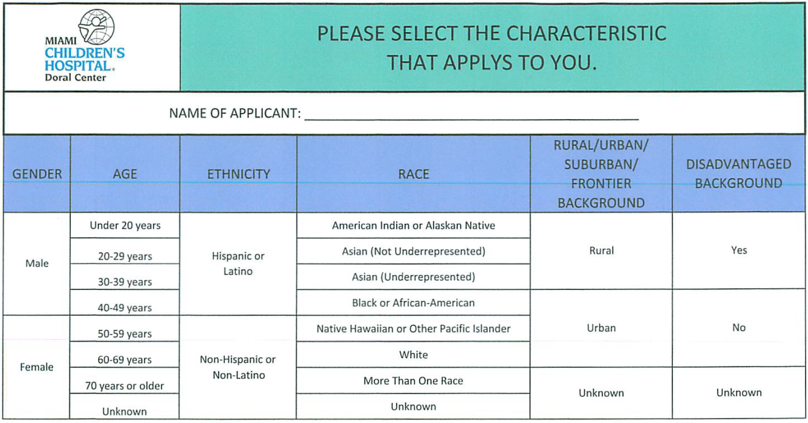

Admission Requirements
Checklist for Application Requirements

1. The applicant must have a DMD of DDS degree, or its equivalent from an ADA
recognized School of Dentistry. US Citizens from foreign dental schools will be considered.
2. Candidates must have a minimum grade point average of 3.00.
3. Application fee $50. Make money order to MCH Pediatric Dentistry Residency.
4. A completed application with two recent 2x2 photographs.
5. Complete PASS application.
6. Register with MATCH.
7. Interview is required for acceptance.

If you may have any questions, please call:
Mrs. Raquel Lugo, DA
Phone: (305) 418-7771
Fax: (305) 418-7777
Submit Application and Supplemental Information (Curriculum Vitae, photographs, and application fee) to:
Mrs. Raquel Lugo, DA
Dr. Rosie Roldan, DMD, MD
Pediatric Dentistry
Miami Children's Hospital
3601 NW 107th Ave 3rd Floor
Doral, FL 33178

